Exam Paper 2016:



Trojan horse: program with hidden side-effects, when run performs some additional task. Used to propagate a virus/worm or install a backdoor. Simply to destroy data.

Virus: infects programs. Modifying them include a copy of the virus. Specific to operating system and hardware.

Worm: replicating program that propagates over net: email, remote exec, login. May disguise itself as a system process.

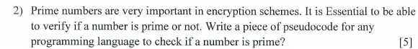

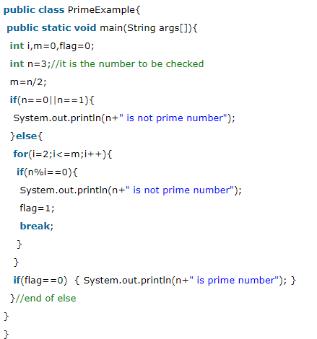

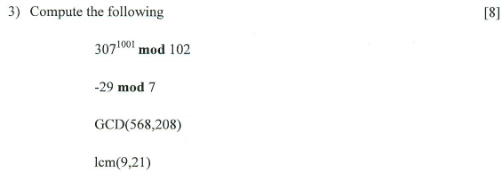



1. baiting
2. scareware
3. phishing
4. spear phishing



2017 Question 1 a



2017 Question 2 c



Google hacking is the use of a search engine, such as Google, to locate a security vulnerability on the Internet.



1. change your passwords
2. use a password manager
3. delete any unused accounts
4. enable two-factor authentication
5. keep software up to date
6. training to identify phishing and spear phishing attacks

n

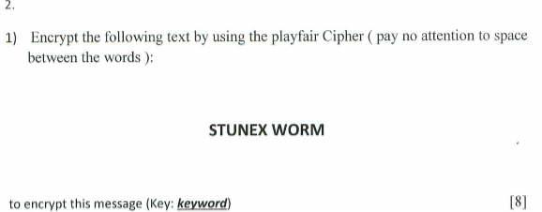

2017 question 1 b

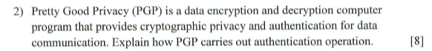

1. the sender creates a message.
2. SHA-1 is used to generate a 160-bit hash code of the message.
3. The hash code is encrypted with RSA using the sender’s private key, and the result is prepended to message.
4. The receiver uses RSA with the sender’s public key to decrypt and recover the hash code
5. The receiver generates a new hash code for the message and compares it with the decrypted hash code. If the two match, the message is accepted as authentic.

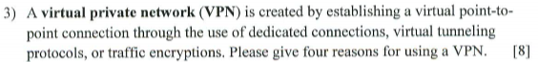

1. Hide your internet activity from ISP
2. Use public WIFI without risks
3. Stop google from tracking you
4. Privacy is your right

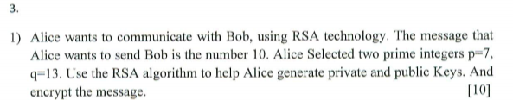

2017 Question 1 c



2017 question 3 a

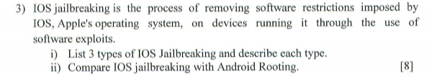

1. Tethered: Tethered jailbreaks require the iOS device to be connected to a computer while it is booting. If it is booted without a computer connected, it will not boot up.
2. Untethered: Untethered jailbreaks do not need the iOS device to be connected to a computer during bootup, making them very user-friendly.
3. Semi-tethered：Semi-tethered and are also based on Boot ROM, LLB or iBoot exploits. But the difference is that the device can be booted without a computer. However, in that case, the device will not be jailbroken.

ii: